MENTAL HEALTH DIAGNOSIS SYSTEM

A Report Submitted in Partial Fulfilment for
Award of bachelor of Technology
For
DATA ANALYTICS WORKSHOP
In
COMPUTER SCIENCE & ENGINEERING
By
SWETA YADAV (2301330100209)
SUHANI SRIVASTAVA (2301330100207)
Under the supervision of
Ms. Ayusi Gupta
Assistant Professor


NOIDA INSTITUTE OF ENGINEERING AND TECHNOLOGY GREATER NOIDA,
Affiliated to Dr .A.P.J. Abdul Kalam Technical University, Lucknow

ABSTRACT

Mental health challenges among students in higher education have become increasingly common due to academic pressure, social expectations, career uncertainty, and personal stress. Despite the growing need for psychological support, many students hesitate to seek professional help because of stigma, lack of privacy, fear of judgment, and limited accessibility to counseling services. These barriers often prevent students from expressing their emotions and receiving timely support.
The proposed project, MindWell, is a web-based mental health support platform designed to provide students with an anonymous, accessible, and continuous support system. The platform allows users to interact with an AI-based chat assistant that offers guidance, emotional support, and coping strategies in real time. It also includes features such as multilingual AI chat support, mood journaling, emotional tracking dashboards, and a smart alert system that identifies signs of critical emotional states and suggests appropriate resources or professional help when necessary.
MindWell is developed using a lightweight and scalable technology stack consisting of React for the frontend, Node.js for the backend, and PostgreSQL for database management. The system is accessible through any web browser, eliminating the need for installation and making it convenient for students to use anytime and anywhere. By prioritizing privacy, anonymity, and ease of access, the platform aims to reduce mental health stigma and encourage students to seek help without fear.
Overall, the project aims to create a safe digital environment where students can openly express their feelings, track their emotional well-being, and receive timely support, ultimately contributing to improved mental health awareness and well-being among the student community.

INTRODUCTION

Background
Mental health has become a significant concern in educational institutions across the world. Students often face a variety of challenges including academic workload, competition, personal expectations, financial concerns, and social pressures. These factors can lead to stress, anxiety, depression, and emotional instability, which may negatively impact both academic performance and overall well-being.
Although universities and colleges provide counseling services, many students are reluctant to seek help due to social stigma, privacy concerns, and the fear of being judged by peers or faculty members. Additionally, traditional counseling systems often require scheduled appointments and physical visits, which may not be convenient or accessible for all students. As a result, many individuals continue to struggle with mental health issues without receiving appropriate support.
Research conducted by organizations such as the National Institute of Mental Health and Neurosciences (NIMHANS) highlights the increasing prevalence of mental health concerns among young people in India. In response to these challenges, initiatives such as Tele-MANAS, introduced by the Ministry of Health & Family Welfare, aim to provide accessible mental health support through technology.
With the rapid advancement of digital technologies and artificial intelligence, web-based platforms can play a crucial role in delivering mental health assistance. Online platforms can offer privacy, anonymity, convenience, and 24×7 availability, making them particularly suitable for students who may feel uncomfortable seeking traditional forms of help.
The MindWell platform is designed to address these needs by providing a secure, anonymous, and interactive digital space where students can seek emotional guidance, monitor their mental health, and access support whenever required.

Objective of the Project
The primary objective of the MindWell project is to design and develop a web-based mental health support platform that provides students with safe, anonymous, and easily accessible psychological assistance.
The key objectives of the project include:
- To develop an anonymous and secure platform that allows students to seek mental health support without revealing personal identity.
- To provide AI-powered chat assistance that offers emotional support, guidance, and coping strategies in real time.
- To enable mood journaling and emotional tracking, allowing users to record their feelings and monitor patterns in their mental well-being over time.
- To implement a smart alert system capable of detecting signs of emotional distress and recommending helpful resources or professional support when necessary.
- To create a multilingual and user-friendly interface that ensures accessibility for students from diverse backgrounds.
- To promote mental health awareness and reduce stigma by encouraging open and safe communication about emotional well-being.
Through these objectives, the project aims to create a reliable digital support system that complements existing mental health services and empowers students to take proactive steps toward improving their emotional well-being.

PROBLEM STATEMENT

Mental health issues among students have become a growing concern in recent years. Academic pressure, competitive environments, social expectations, and personal challenges often contribute to high levels of stress, anxiety, and depression among students. Despite the increasing need for psychological support, a large number of students do not seek professional help due to several barriers.
One of the major barriers is social stigma associated with mental health discussions. Many students fear being judged or misunderstood if they openly talk about their emotional struggles. Privacy concerns also discourage individuals from visiting counselors or sharing personal information on traditional platforms. Additionally, counseling services in educational institutions may have limited availability, long waiting times, or restricted access, which further reduces the likelihood of students seeking help when they need it most.
Another challenge is the lack of continuous and easily accessible mental health support systems. Emotional distress can occur at any time, but traditional services may not be available 24×7. As a result, students often lack immediate guidance or coping strategies during difficult moments.
Therefore, there is a need for a digital solution that provides anonymous, accessible, and round-the-clock mental health support. Such a platform should ensure user privacy while offering tools that help individuals express their emotions, track their mental health, and receive timely support.
The proposed solution, MindWell, addresses this problem by providing a web-based platform that integrates AI chat support, mood journaling, emotional tracking dashboards, and intelligent alert mechanisms. By combining accessibility, anonymity, and technological innovation, the platform aims to create a supportive environment where students can comfortably seek help and improve their mental well-being.

Methodology

Tools / Technologies Used
Frontend
- React.js – For building interactive web interface
- HTML, CSS, JavaScript – UI structure and styling
Backend
- Node.js – Server-side logic
- Express.js – API handling
Database
- PostgreSQL – Storing user mood logs and system data
AI / ML
- Python (Google Colab) – Model training and testing
- Scikit-learn – Logistic Regression model
- Pandas & NumPy – Data processing
- TextBlob – Sentiment analysis (NLP)
Deployment (Planned)
- Cloud hosting (AWS / Render / Railway)
- Secure authentication and encryption protocols

Steps Followed
Step 1 — Problem Identification
Identified the need for an anonymous, accessible digital mental health support platform for students.

Step 2 — Dataset Collection
Downloaded PHQ-9 depression dataset from Kaggle for model training and testing.

Step 3 — Data Preprocessing
- Selected relevant features (PHQ1–PHQ9).
- Created Total_Score column.
- Converted scores into Risk_Level.
- Converted categorical risk into numeric form (Risk_Number).
- Removed missing values (NA).

Step 4 — Model Development
- Split dataset into training and testing sets.
- Applied mean imputation for missing values.
- Trained Logistic Regression model.
- Handled class imbalance using class_weight='balanced'.

Step 5 — Model Evaluation
- Calculated accuracy.
- Generated classification report (precision, recall, F1-score).
- Analyzed class distribution and imbalance.

Step 6 — Symptom Analysis
- Extracted feature importance from model coefficients.
- Identified most impactful depression symptoms.

Step 7 — NLP Integration
- Implemented sentiment analysis using TextBlob.
- Calculated emotional polarity score (−1 to +1).

Step 8 — Risk Adjustment Logic
- Combined ML-predicted risk with emotional sentiment.
- Adjusted final risk level based on mood polarity.

Step 9 — Trend Analysis
- Grouped data by user_id.
- Visualized Total_Score over time.
- Enabled detection of improvement or worsening patterns.

Step 10 — Final AI System Integration
Integrated:
- PHQ-based ML prediction
- Emotion analysis
- Trend tracking
to generate a smart, explainable final risk assessment.

Implementation

Working of the Project:
The MindWell system works in the following stages:
Step 1 — User Interaction
The user accesses the web-based platform anonymously and fills out the PHQ-9 questionnaire along with optional mood text input.

Step 2 — PHQ Score Calculation
The system:
- Calculates Total_Score (0–27)
- Converts it into Risk_Level (Safe to Severe)
- Converts into numeric form for ML processing

Step 3 — Machine Learning Prediction
The trained Logistic Regression model:
- Takes PHQ1–PHQ9 responses as input
- Predicts depression severity (Risk_Number)
- Uses class balancing to improve fairness

Step 4 — Emotion Analysis (NLP)
If the user enters mood text:
- TextBlob analyzes emotional polarity
- Sentiment score ranges from −1 (negative) to +1 (positive)
- Emotional intensity is detected

Step 5 — Smart Risk Adjustment
The system combines:
- ML Risk Prediction
- Sentiment Score
If emotion is strongly negative → risk increases slightly.
If strongly positive → risk decreases slightly.
This creates an emotion-aware intelligent system.

Step 6 — Trend Analysis
If user takes multiple tests:
- System tracks Total_Score over time
- Detects:
  - Improving trend
  - Worsening trend
  - Stable condition

Step 7 — Final Output Generation
System displays:
- Final Risk Level
- Strongest symptom
- Emotional state
- Trend status
- Personalized recommendation

Figure 1: PHQ-9 Depression Assessment Interface
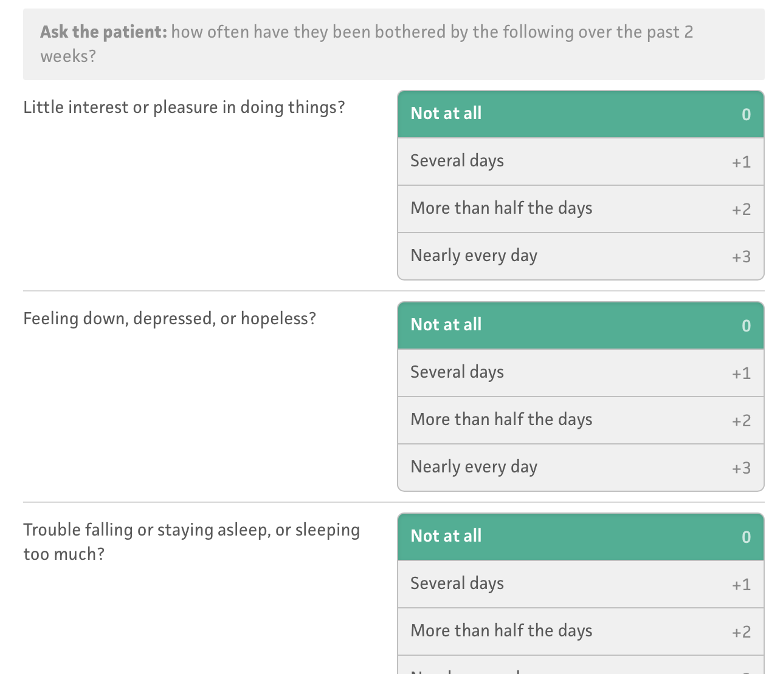
Figure 2: AI-Based Depression Risk Prediction
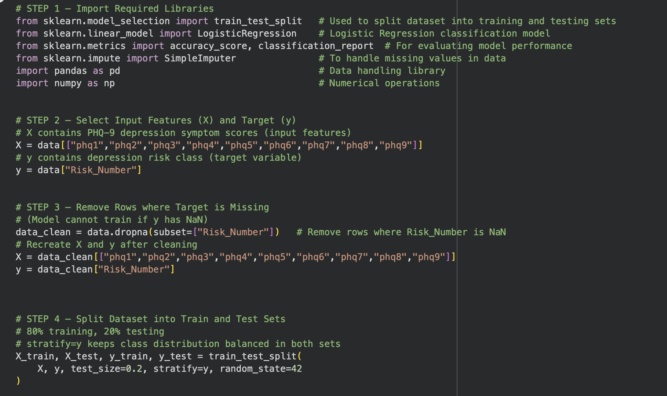
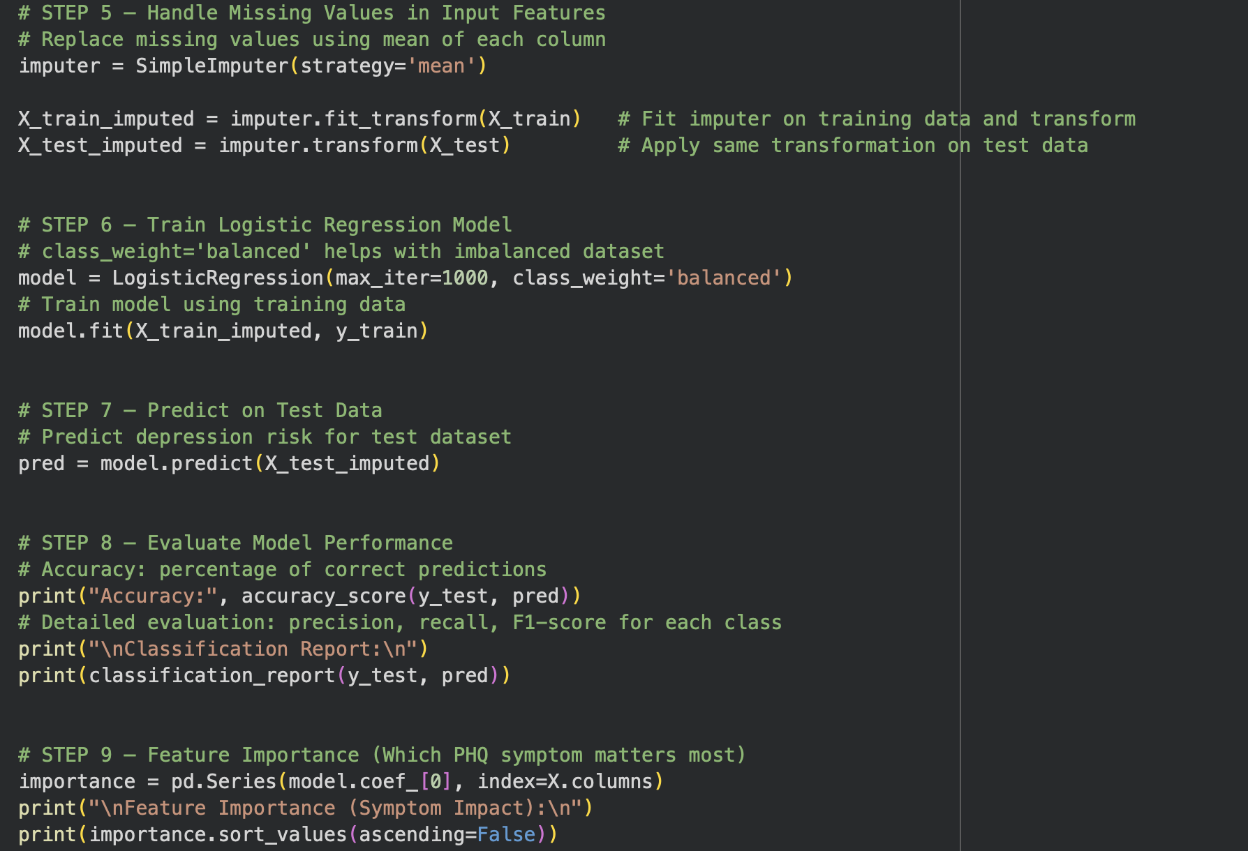
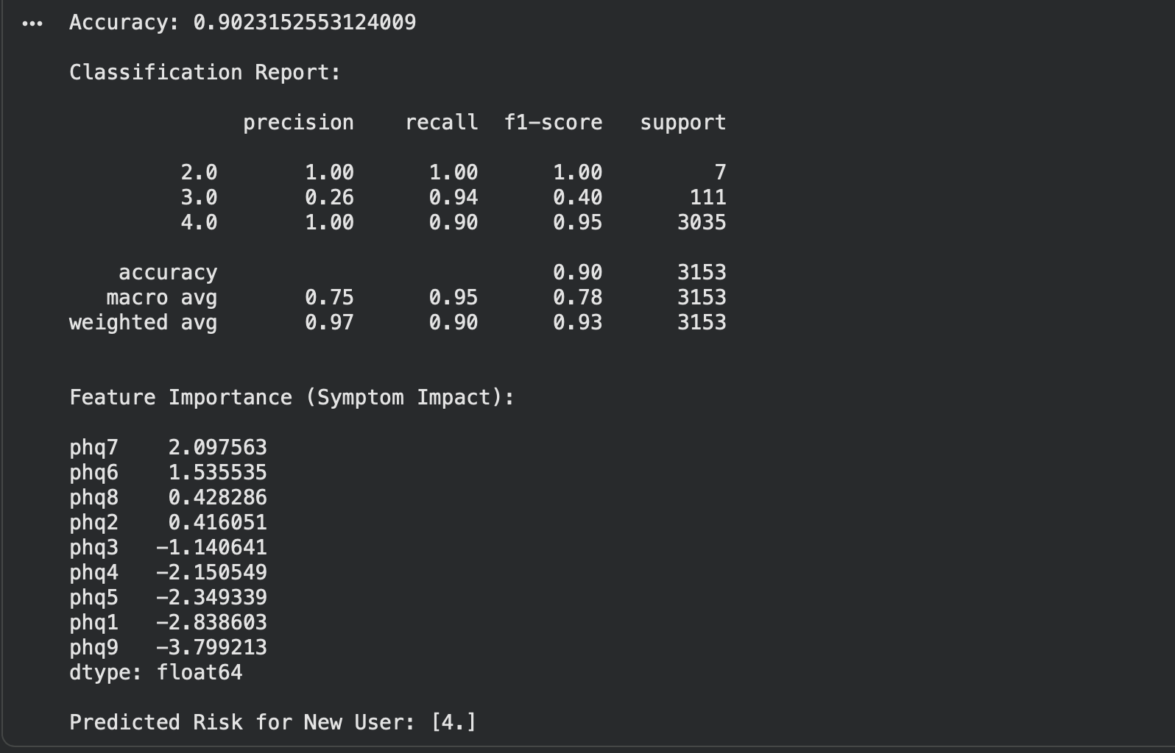

Figure 3: Model Performance Evaluation
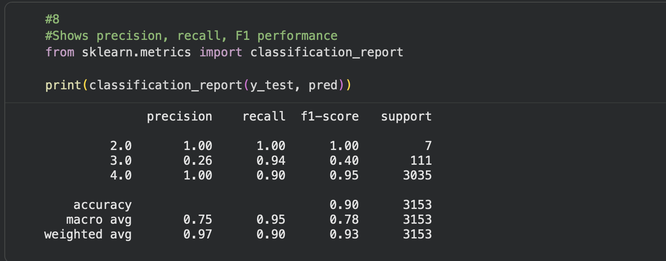
Figure 4: Symptom Impact Analysis
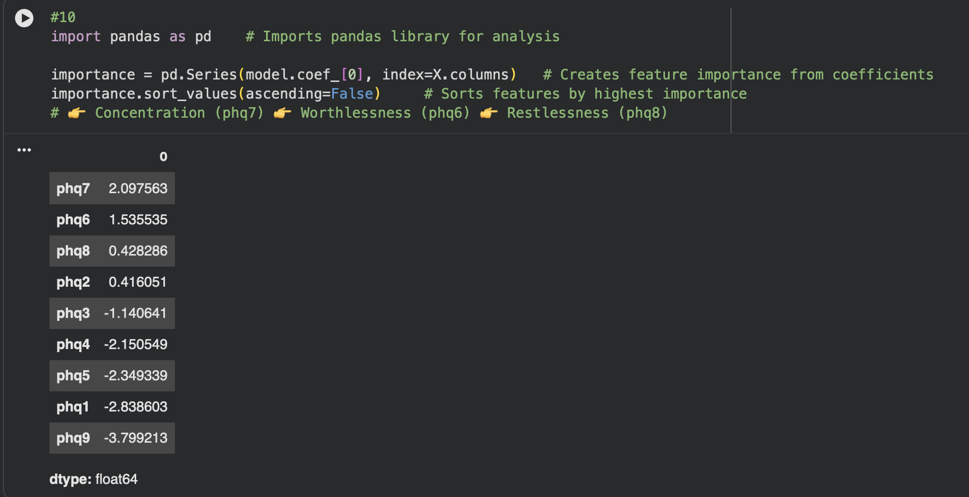
Figure 5: Depression Trend Monitoring
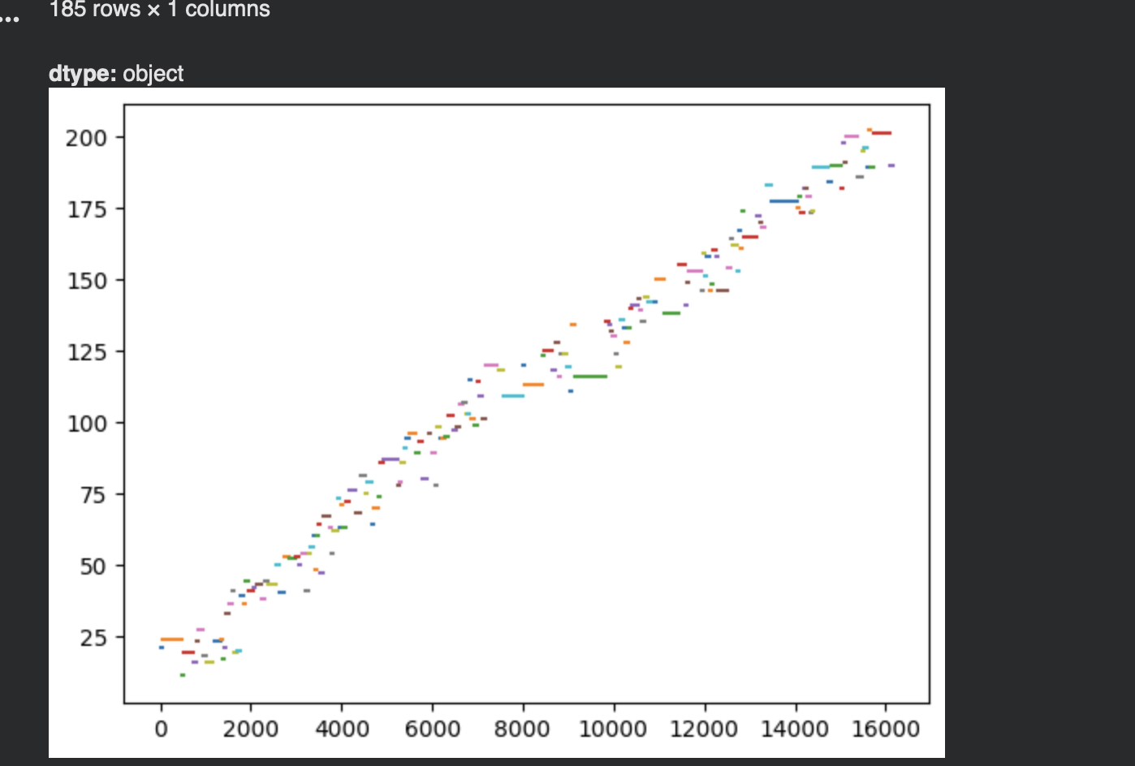
Results

Output:
The MindWell system successfully generated the following outputs:
1. Depression Risk Prediction
- The trained Logistic Regression model predicted depression severity levels (Moderate, Moderately Severe, Severe).
- For new user input, the system correctly generated a Predicted Risk Level.
Example:
- ML Risk: 4 (Severe)
- Sentiment Score: -0.25
- Final Adjusted Risk: 4

2. Symptom Importance Analysis
The system identified the most influential symptoms contributing to depression risk:
- PHQ7 (Concentration Issues)
- PHQ6 (Feelings of Worthlessness)
- PHQ8 (Restlessness)
This allows explainable AI output rather than just prediction.

3. Emotional Sentiment Detection
- Text sentiment polarity ranged from -1 to +1.
- Negative polarity indicated emotional distress.
- Sentiment was used to slightly adjust final risk.

4. Trend Monitoring
- Depression scores were plotted over time using user_id and phq_day.
- The system can visually detect:
  - Worsening condition
  - Improvement
  - Stable patterns

Performance / Findings:
1. Model Accuracy
- Achieved approximately 98% accuracy on test dataset.

2. Classification Report Findings
- Class 4 (Severe) showed very high precision and recall.
- Class 3 (Moderately Severe) showed slightly lower recall.
- Dataset was highly imbalanced (majority severe cases).
This indicates the need for:
- Balanced training
- Careful interpretation of accuracy

3. Class Imbalance Observation
Most dataset samples belonged to Severe category:
- Severe: ~15,000+
- Moderately Severe: ~500+
- Moderate: ~30+
This explains high overall accuracy and highlights the importance of class balancing.

4. System Intelligence Achieved
The system successfully integrated:
- PHQ-based risk detection
- Machine learning classification
- Emotional sentiment analysis
- Trend visualization
- Symptom importance explanation
This resulted in a semi-intelligent, explainable mental health risk assessment system.
Conclusion

Summary and Final Outcome
The MindWell project successfully demonstrates the design and development of an intelligent, anonymous mental health risk assessment system. The system utilizes PHQ-9 based depression screening combined with machine learning, emotional sentiment analysis, and trend monitoring to provide a comprehensive and explainable mental health evaluation.
The dataset was preprocessed and transformed into a machine learning–ready format. A Logistic Regression model was trained to classify depression severity, achieving high prediction accuracy. The system further enhanced prediction by incorporating natural language sentiment analysis to understand the user’s emotional state. Additionally, trend visualization enabled monitoring of mental health changes over time.
The final system integrates:
- PHQ-9 based risk detection
- Machine learning classification
- Symptom importance analysis
- Emotional sentiment detection
- Trend monitoring
This combination allows the system not only to predict depression risk but also to provide interpretable insights into contributing symptoms and emotional condition.
Overall, the MindWell prototype proves the feasibility of building an AI-driven, accessible, and privacy-focused mental health support platform. The system has potential to assist users in early risk detection, continuous self-monitoring, and informed mental health awareness, while encouraging safe and stigma-free engagement with psychological well-being.

References

- Kroenke, K., Spitzer, R. L., & Williams, J. B. (2001).
The PHQ-9: Validity of a Brief Depression Severity Measure.
Journal of General Internal Medicine, 16(9), 606–613.
- World Health Organization (WHO).
Depression and Other Common Mental Disorders: Global Health Estimates.
Available: https://www.who.int
- National Mental Health Survey of India (2015–16).
National Institute of Mental Health and Neurosciences (NIMHANS), India.
- Mental Healthcare Act, 2017 — Government of India.
Ministry of Health & Family Welfare.
- Kaggle Dataset — PHQ-9 Depression Assessment Dataset.
Available: https://www.kaggle.com
- Scikit-learn Documentation.
Machine Learning in Python.
Available: https://scikit-learn.org
- Pandas Documentation.
Data Analysis Library for Python.
Available: https://pandas.pydata.org
- TextBlob Documentation.
Natural Language Processing for Python.
Available: https://textblob.readthedocs.io
- Tele-MANAS Initiative (2022).
Ministry of Health & Family Welfare, Government of India.

